Activity 14.3

1. Text

   Description automatically generated
2. 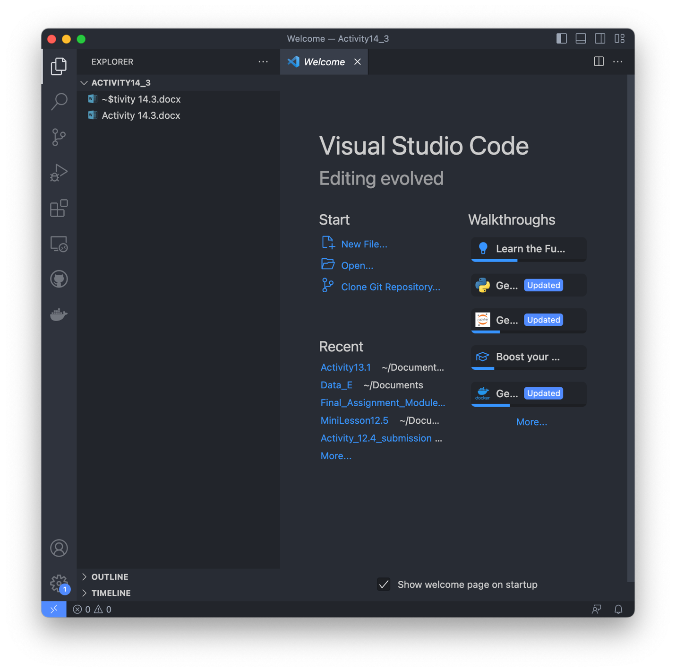
3. A screenshot of a computer

   Description automatically generated with medium confidence
4. 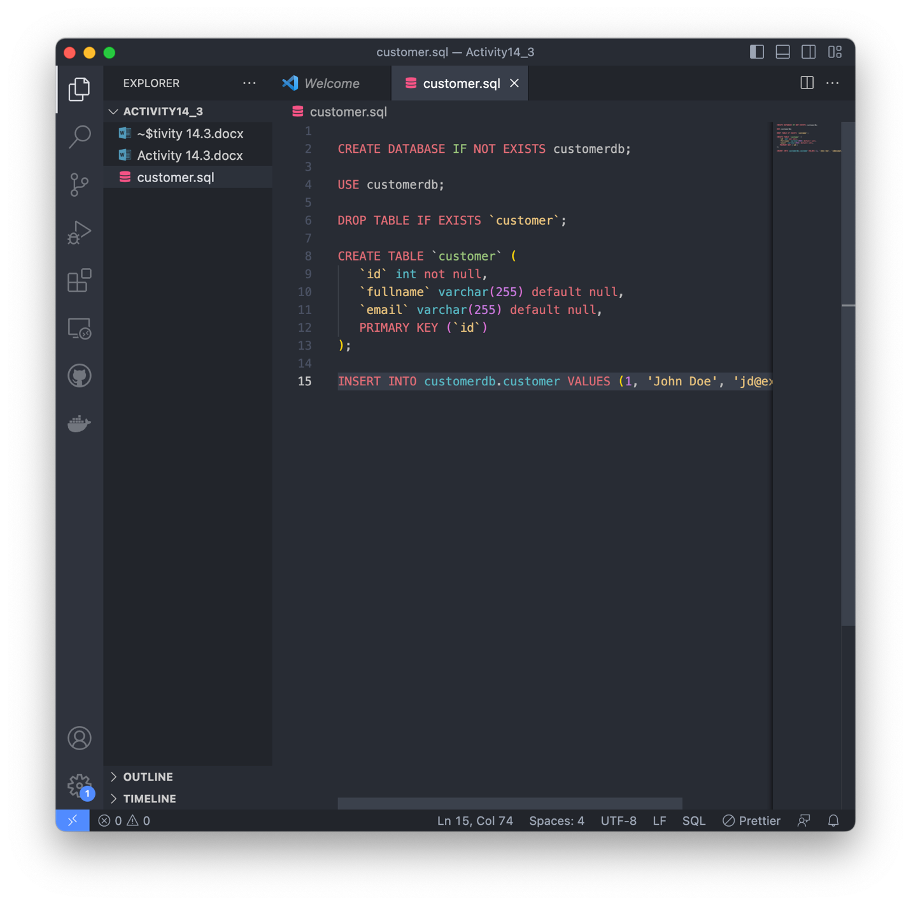
5. Graphical user interface, application

   Description automatically generated
6. 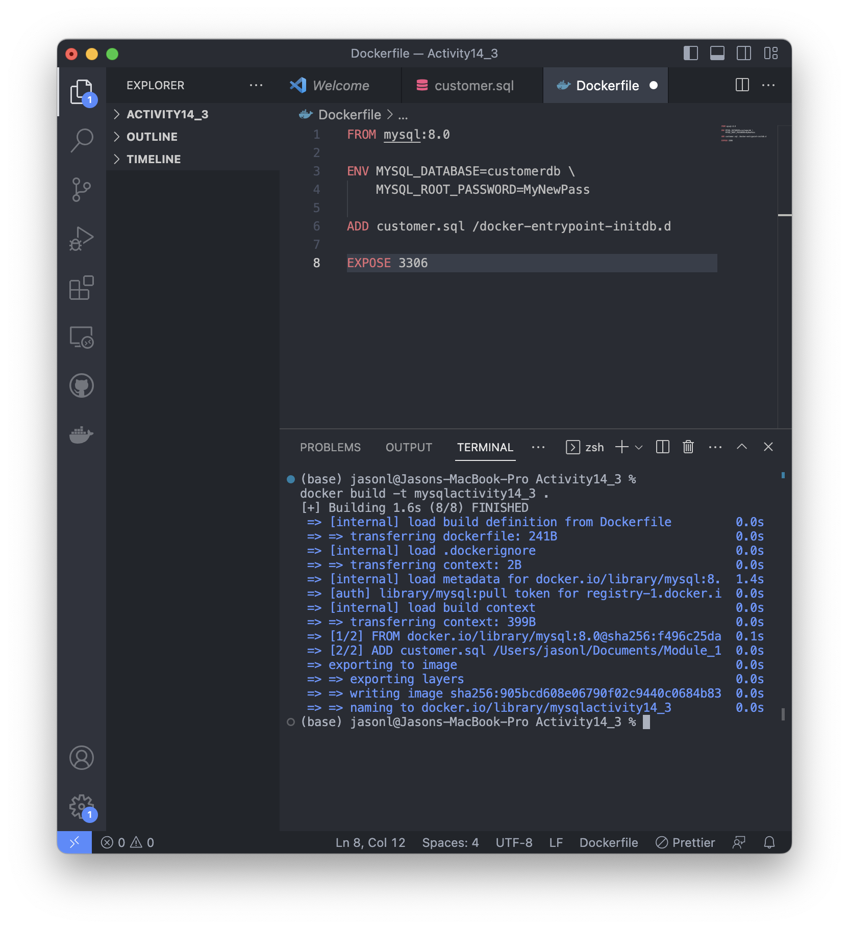
7. 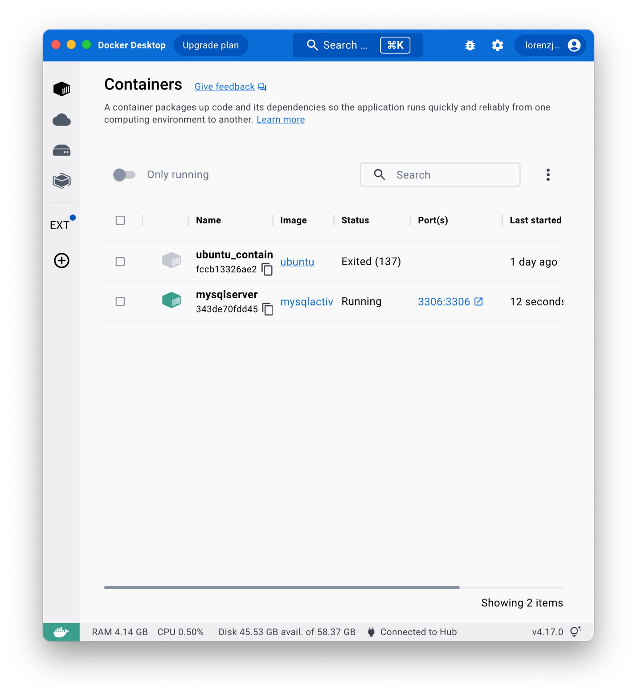
8. 